EXECUTIVE SALES DASHBOARD ANALYSIS
Data Analyst Portfolio Project
Prepared by
Fathima Arshi
Tools Used
- Microsoft Excel
- Pivot Tables
- Pivot Charts
- Slicers & Timeline
- Dashboard Design
Dataset
Superstore Sales Dataset (Kaggle)

July 2026

TABLE OF CONTENTS
Contents

Executive Summary 3
Business Objectives 3
Dataset Overview 4
Data Preparation & Cleaning 5
KPI Analysis 6
Dashboard Overview 7
Business Insights 9
Business Recommendations 10
Skills Demonstrated 11
Conclusion 11

Executive Summary
This project presents an interactive Executive Sales Dashboard developed using Microsoft Excel to analyse sales performance from the Superstore Sales Dataset. The objective was to transform raw transactional data into meaningful business insights through data preparation, KPI calculations, Pivot Tables, Pivot Charts, and an interactive dashboard.
The analysis evaluates key business metrics, including total sales, total profit, distinct orders, customer count, average order value, profit margin, and average discount. Sales performance was examined across regions, product categories, customer segments, and monthly trends to identify patterns and opportunities for improvement.
The final dashboard enables users to explore the data dynamically using slicers and a timeline, allowing efficient filtering by region, category, segment, and year. Based on the analysis, several business insights and recommendations were identified to support data-driven decision-making.
This project demonstrates practical Excel skills in data cleaning, analysis, visualization, dashboard development, and business reporting, reflecting the responsibilities commonly performed by Data Analysts and Business Analysts.

Business Objectives
The primary objective of this project was to develop an interactive Excel dashboard that analyzes sales performance and provides meaningful business insights from the Superstore Sales Dataset. The dashboard was designed to help business users monitor key performance indicators (KPIs), identify sales trends, and support data-driven decision-making.
The project focuses on the following objectives:
- Analyze overall sales and profitability across the business.
- Monitor key performance indicators such as Total Sales, Total Profit, Distinct Orders, Average Order Value, Profit Margin, Quantity Sold, Customer Count, and Average Discount.
- Evaluate sales and profit performance across different regions.
- Compare sales performance across product categories and customer segments.
- Identify monthly sales and profit trends.
- Recognize the top-performing customers and best-selling products.
- Create an interactive dashboard using Pivot Tables, Pivot Charts, Slicers, and a Timeline for dynamic data exploration.
- Present business insights and recommendations to support strategic decision-making.

Dataset Overview
The Superstore Sales Dataset, sourced from Kaggle, was used for this analysis. This publicly available retail dataset contains transactional sales records and is widely used for data analysis, business intelligence, and dashboard development projects. It provides detailed information on customer orders, product sales, profitability, shipping, and geographical distribution, making it suitable for evaluating business performance and identifying sales trends.
The dataset consists of 9,994 records and 21 columns, with each row representing an individual product within a customer order. It includes important business attributes such as Order ID, Order Date, Ship Date, Customer Name, Segment, Region, Category, Sub-Category, Product Name, Sales, Quantity, Discount, and Profit. These fields provide the foundation for analyzing customer behavior, product performance, regional sales, and overall business profitability.
For this project, the dataset was prepared for analysis by validating the data structure and ensuring compatibility with Microsoft Excel. Additional calculated columns, including Order Year, Order Month, Month Number, Shipping Days, and Profit Margin, were created to support KPI calculations, trend analysis, and interactive dashboard development. These enhancements enabled a more comprehensive analysis and improved the effectiveness of the final dashboard.
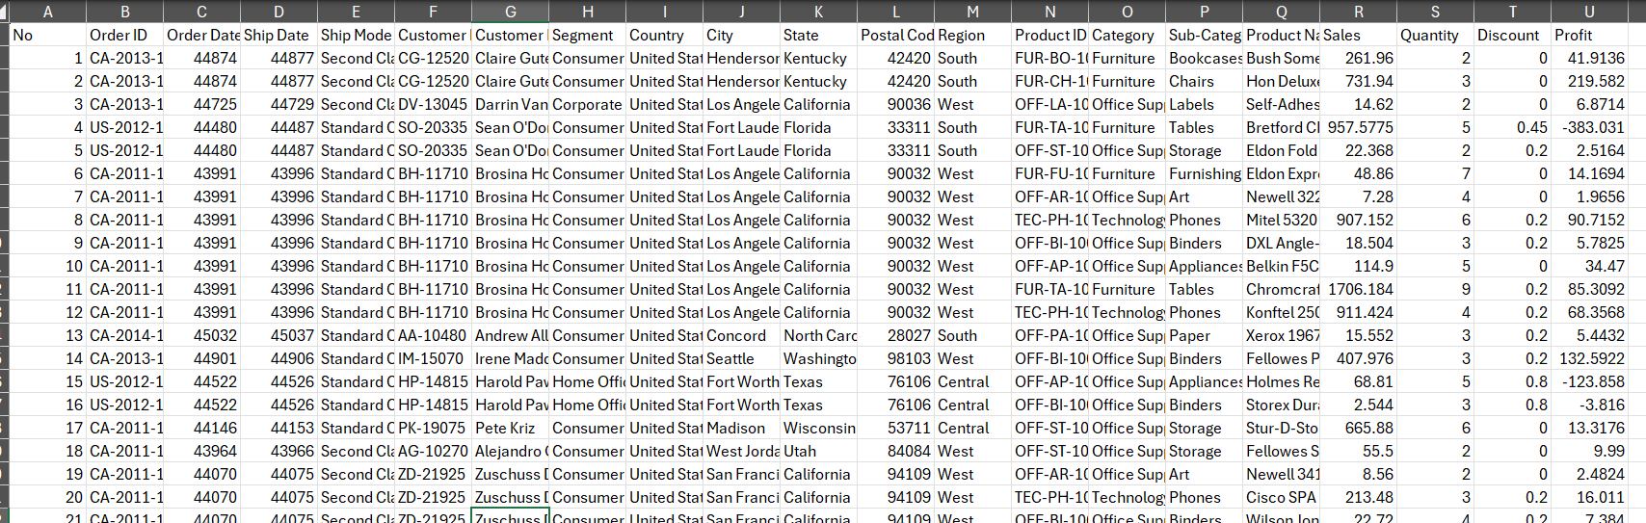
Figure 1. Preview of the Superstore Sales Dataset used for analysis.

Data Preparation & Cleaning
Before conducting the analysis, the Superstore Sales Dataset was reviewed to ensure that it was suitable for reporting and dashboard development. The dataset was examined for data quality, structure, and consistency to ensure accurate analysis and reliable business insights.
The Order Date and Ship Date fields were initially stored in an inconsistent format. These columns were converted into valid Excel date formats, enabling accurate time-based analysis, including monthly trends, yearly comparisons, and timeline filtering within the dashboard.
To improve data management and analysis, the dataset was converted into an Excel Table. This provided structured references, automatic expansion when adding data, and simplified the creation of Pivot Tables, Pivot Charts, and dashboard components.
Several calculated columns were created to enhance the analysis. These included Order Year, Order Month, and Month Number, which were used to organize and visualize sales trends over time. A Shipping Days column was also created to calculate the time taken between order placement and shipment. Additionally, a Profit Margin column was developed to evaluate profitability as a percentage of sales.
Finally, the prepared dataset was used to calculate key performance indicators (KPIs) and generate Pivot Tables that formed the foundation of the interactive dashboard. These preparation steps ensured that the analysis was accurate, organized, and suitable for business reporting.
After preparing the dataset, multiple Pivot Tables were developed to summarize sales across regions, categories, customer segments, and monthly trends. These Pivot Tables served as the foundation for the dashboard visualizations.
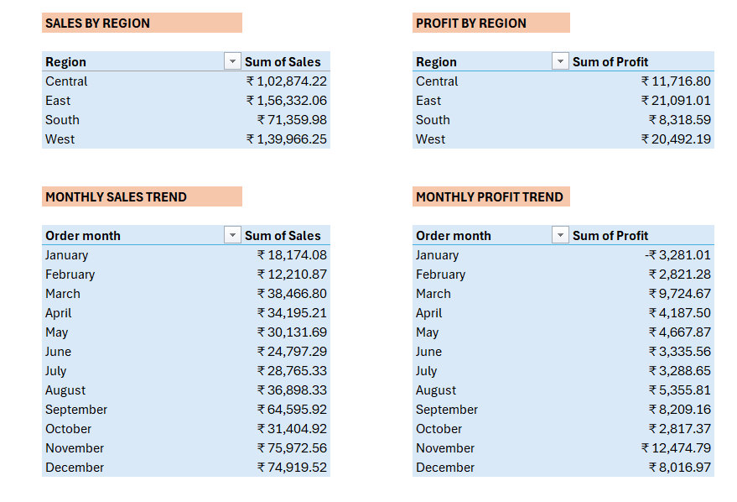
Figure 2. - Sample Pivot Tables Created During Analysis

KPI Analysis
Key Performance Indicators (KPIs) were developed to provide a high-level overview of the organization's overall business performance. These metrics summarize large volumes of transactional data into meaningful information that supports performance monitoring and strategic decision-making. The dashboard includes eight KPIs that evaluate sales performance, profitability, customer activity, and operational efficiency.
Total Sales represents the total revenue generated during the analysis period. This KPI provides an overall measure of business performance and serves as one of the primary indicators of revenue growth.
Total Profit measures the overall profit earned after accounting for costs. Comparing profit with total sales helps evaluate the financial health of the business and determine whether revenue growth is translating into profitability.
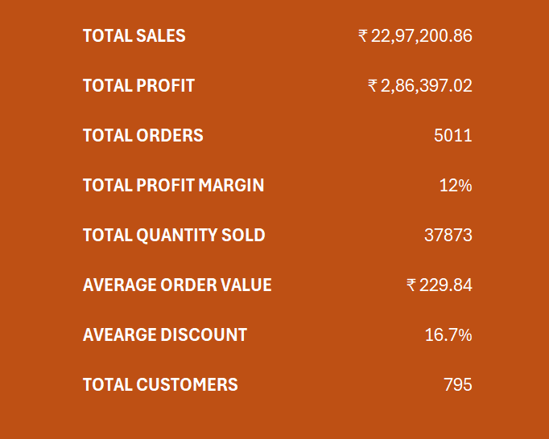
Figure 3 - KPI Cards
Distinct Orders represents the total number of unique customer orders placed during the analysis period. Unlike counting individual transaction rows, this metric counts each order only once, providing a more accurate measure of customer purchasing activity.
Total Customers indicates the number of unique customers who placed orders. This KPI helps evaluate customer reach and supports analysis of customer acquisition and retention.
Quantity Sold measures the total number of product units sold. This metric provides insight into product demand and sales volume across the business.
Average Order Value (AOV) represents the average revenue generated per customer order. It is calculated by dividing Total Sales by the number of Distinct Orders. Monitoring AOV helps businesses understand customer purchasing behaviour and identify opportunities to increase revenue per transaction.
Profit Margin measures profitability as a percentage of total sales. This KPI indicates how efficiently the business converts revenue into profit and is commonly used to evaluate overall financial performance.
Average Discount represents the average discount applied across all transactions. Monitoring this metric helps assess pricing strategies and understand the impact of discounts on sales performance and profitability.
Together, these KPIs provide a comprehensive overview of business performance and form the foundation of the interactive dashboard.

Dashboard Overview
The Executive Sales Dashboard was developed in Microsoft Excel to provide an interactive and comprehensive view of the organization's sales performance. The dashboard consolidates key business metrics and visualizations into a single interface, enabling users to monitor performance efficiently and make informed business decisions.
The dashboard begins with eight Key Performance Indicators (KPIs) that summarize the organization's overall performance. These KPIs include Total Sales, Total Profit, Distinct Orders, Total Customers, Quantity Sold, Average Order Value (AOV), Profit Margin, and Average Discount. Together, these metrics provide a quick overview of the business's financial and operational performance.
To analyze trends over time, the dashboard includes Monthly Sales Trend and Monthly Profit Trend line charts. These visualizations help identify seasonal patterns and monitor changes in business performance across different months.
Regional performance is presented through Sales by Region and Profit by Region column charts, allowing users to compare the contribution of each region to overall sales and profitability. Additional visualizations display Sales by Category and Sales & Profit by Segment, enabling comparisons across product categories and customer segments. The dashboard also includes Top 10 Customers and Top 10 Products charts, which highlight the highest contributors to sales. These visualizations help identify valuable customers and best-selling products that drive business growth.
To enhance user interaction, the dashboard incorporates Slicers for Region, Category, and Segment, along with a Timeline for filtering data by Order Date. These interactive controls allow users to explore the data dynamically and customize the analysis based on specific business requirements.
Overall, the dashboard presents complex sales data in a clear, organized, and interactive format, enabling users to gain meaningful insights and support data-driven decision-making.
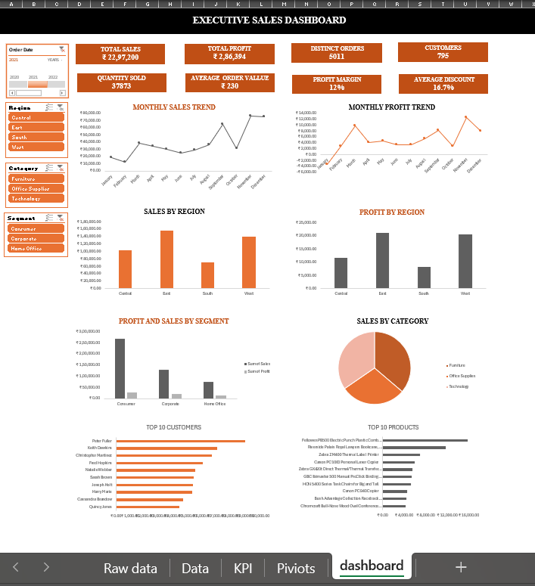

Figure 4. Executive Sales Dashboard developed in Microsoft Excel.

Business Insights
The analysis of the Superstore Sales Dataset provided several valuable insights into the company's sales performance, profitability, customer behaviour, and product performance.
The business generated total sales of ₹22,97,200 and total profit of ₹2,86,394, resulting in an overall profit margin of approximately 12%. This indicates that the company maintains a positive level of profitability while generating consistent revenue.
Regional analysis revealed that the West region contributed the highest sales and profit among all regions. This suggests strong market performance and customer demand in the region. In contrast, the South region recorded comparatively lower sales, indicating potential opportunities for business growth through targeted marketing or sales initiatives.
The Technology category emerged as the highest-performing product category in terms of sales, followed by Furniture and Office Supplies. This indicates that technology products contribute significantly to overall business revenue and should remain a strategic focus.
Customer segment analysis showed that the Consumer segment generated the highest sales compared to Corporate and Home Office customers. This suggests that individual consumers represent the company's largest customer base and play a key role in driving revenue.
Monthly sales and profit trends indicated noticeable fluctuations throughout the year, with stronger performance during the final quarter. This pattern suggests increased customer demand during the year-end period, emphasizing the importance of effective inventory planning and promotional activities.
The analysis also identified several high-value customers and best-selling products that contribute significantly to total sales. Maintaining strong relationships with these customers and ensuring the availability of top-performing products can support continued business growth.
Overall, the dashboard demonstrates that while the business performs well across several key areas, opportunities remain to improve sales in lower-performing regions and optimize pricing and promotional strategies to further enhance profitability.

Business Recommendations
Based on the findings from the sales analysis, several recommendations can be made to improve overall business performance and support future growth.
The company should continue investing in the Technology category, as it generated the highest sales among all product categories. Expanding the product range, maintaining adequate inventory, and introducing targeted promotional campaigns could further increase revenue in this category.
Since the West region demonstrated the strongest sales performance, the business should continue strengthening its presence in this market while identifying the factors contributing to its success. At the same time, additional marketing campaigns and customer engagement initiatives should be implemented in lower-performing regions to improve sales performance.
The analysis showed that the Consumer segment contributed the largest share of sales. Developing customer loyalty programs, personalized offers, and targeted marketing strategies could help retain existing customers and encourage repeat purchases.
Sales and profit increased during the final quarter of the year, indicating seasonal demand. The business should prepare for this period by increasing inventory levels, optimizing staffing, and planning promotional campaigns in advance to maximize sales opportunities.
The organization should also regularly monitor its discount strategy. While discounts can increase sales volume, excessive discounting may reduce overall profitability. A balanced pricing strategy should be maintained to support both revenue growth and profit margins.
Finally, the company should continue monitoring its top-performing products and high-value customers. Maintaining product availability and strengthening relationships with valuable customers can contribute to long-term business growth and customer retention.

Skills Demonstrated
This project demonstrates a range of technical and analytical skills required for Data Analyst and Business Analyst roles. Microsoft Excel was used to prepare, analyse, visualize, and present business data through an interactive dashboard.
The project involved data preparation techniques such as formatting date fields, creating calculated columns, and organizing the dataset for analysis. Pivot Tables and Pivot Charts were used to summarize and visualize business information, while interactive Slicers and a Timeline enhanced the dashboard's usability.
The development of KPI cards required the application of Excel formulas and analytical thinking to calculate key business metrics, including Total Sales, Total Profit, Distinct Orders, Average Order Value, Profit Margin, and Average Discount. The project also demonstrates dashboard design principles, data visualization best practices, business reporting, and the ability to communicate analytical findings through business insights and recommendations. The project demonstrates proficiency in Pivot Tables for data summarization and Pivot Charts for interactive data visualization.
Overall, this project reflects practical skills in data analysis, business intelligence, and decision-support reporting using Microsoft Excel.

Conclusion
The Executive Sales Dashboard project demonstrates how Microsoft Excel can be used to transform raw sales data into meaningful business insights through data analysis and visualization. By combining data preparation, KPI calculations, Pivot Tables, Pivot Charts, and interactive dashboard features, the project provides a comprehensive view of sales performance across different regions, product categories, customer segments, and time periods.
The analysis identified key trends in sales and profitability while highlighting opportunities to improve business performance through informed decision-making. The interactive dashboard enables users to explore data efficiently using slicers and a timeline, making it a practical reporting tool for business users.
This project strengthened practical skills in Microsoft Excel, data analysis, dashboard development, business reporting, and data visualization. It also demonstrates the ability to convert business data into actionable insights, reflecting the responsibilities commonly expected of Data Analysts and Business Analysts.

